*^Dan 4:16, 23, 25, 32- “seven times”
^Dan 8:14- “two thousand and three hundred days”
*“Time” - Strong’s “iddan” -a fixed or appointed time and technically means a year
- see also Lev 26:18, 21, 24, 28
- “A ‘time’ in Jewish reckoning is a year” –Bro Mansfield
- A prophetic year is 360 days (Scriptural month = 30 days, see Gen 7:11, 8:3-4)
- 360 is rounded mean of solar and lunar years
^“Day-for-a-year” principle- Num 14:34 (punishment/prophecy of the wandering)
- Ezek 4:6 (punishment/prophecy of the siege of Jerusalem by Nebuchadnezzar-
430 days- and from this siege and captivity to the Maccabean revolt- 430
years)- for details, see commentary by Mansfield, Thomas, Matthew Henry, or
Adam Clarke
- Lk 13:32 (Christ’s ministry described by 3 days)

Seven Times
“seven times” = 7 literal years for Nebuchadnezzar (Dan 4:32-34)
Also 7 prophetical years of the “kingdom of men” (vs. 17, 25, 32)…
7 times = 7 years (see above)
7 years x 360 days (scriptural, Jewish, and prophetic year) = 2520 days
2520 days = 2520 years (day-for-a-year principal)
-604 (BC- Nebuchadnezzar’s “head of gold” reign begins, Jerusalem besieged)
+ 2520 years
+ 1 year (accounting for “year 0”)
= 1917 AD (Balfour Declaration, Palestine/Jerusalem freed from Gentile rule, kingdom of men ends, “time of the end” from Dan 11:40 begins, etc)

“If the year 604 BC witnessed the rise of typical Babylon, the supremacy over the typical Israel, what event is the corresponding year (604 BC + 2520 = 1917) likely to witness? The fall of the anti-typical Babylon- the extinction of Gentile supremacy on earth and the restoration of Judah’s throne in the person of Christ. The secret things belong to God; it is not for us to say: but there can be no question that those who live to see this year, 1917, will have reached one of the most important, perhaps the most momentous, of these terminal years of crisis.” -Dr. Grattan Guinness, Light for the Last Days (1886)

2300 Days
2300 days = 2300 years (day-for-a-year principal)
-334 (BC- Grecian kingdom under Alexander begin)
+ 2300 years
+ 1 year (accounting for “year 0”)
= 1967 (Jerusalem returned to Jews in Six Day War)
*note* The focus of Dan 8’s prophecy is the origin of Alexander’s kingdom and what became of it after. From out of that kingdom came the “little horn” who took away the “daily sacrifice” and cast down the “place of his sanctuary”, referencing the temple practices in Jerusalem. Thus, the prophecy’s interpretation must commence from Alexander and be related to a restoration of Jerusalem to some extent.

“I will add a few words here touching the probable time when the Sanctuary will be cleansed. The principal difficulty consists in fixing the terminus a quo or the epoch from which the 2300 years is to be reckoned. It seems most probable however, that this period is to be reckoned, not from the rise or birth of the ram, as some writers have alleged (for he was in his full strength and vigor when Daniel first saw him), but from the time when he was first attacked by the he-goat. If this assumption is warranted by the context, it fixes the beginning of this period to the spring of the year 334 BC, and consequently, it will terminate in the spring or about the middle of AD 1967” - R. Milligan, Reason and Revelation (1868)
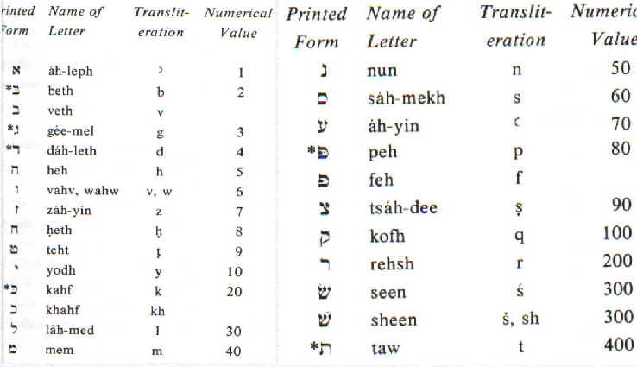

Mene, Mene, Tekel Upharsin (no vowels in Hebrew)

M- 40

N- 50

= 90 x 2 = 180 (A)

T- 400

K- 20

L- 30

= 450 (B)

P(h)- 80

R- 200

S- 300

N- 50

= 630 (C)

180 (A) + 450 (B) + 630 (C) = 1260
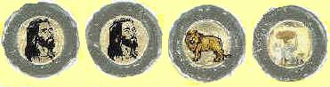
Coins in Hebrew ==> | 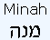 |  | 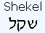 | 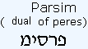 | Total values
Value in  shekels | 50 shekels | 50 shekels | 1 shekel | 25-shekels  (half mina) | = 126 shekels,  or, 2,520  gerahs
 | = 100 shekels
Value in  Gerahs | 1,000 | 1,000 | 20 | 500 | =  2,520  gerahs
 | = 2,000

Ez 45:12 (KJV) And the shekel shall be twenty gerahs: twenty shekels, five and twenty shekels, fifteen shekels, shall be your maneh.
-“That is, 60 shekels; the common mina was 50 shekels.” –studylight.org

Ez 45:12 (RSV) The shekel shall be twenty gerahs; five shekels shall be five shekels, and ten shekels shall be ten shekels, and your mina shall be fifty shekels.
-“But it is thus reckoned because they had one piece of money that weighed twenty shekels, another twenty-five, another fifteen” –Matthew Henry

Arabic names of 3 weights translated into Hebrew: “A Mina, a Mina, a Shekel, and a half-Mina”
From Ez 45:12:
20 Gerahs = 1 Shekel
50 Shekels = 1 Mina (“maneh”)
1 Mina = 1,000 Gerahs
(Gerahs are the lowest common denominator of weights)

A Mina 1,000 Gerahs
A Mina 1,000 Gerahs
A Shekel 20 Gerahs
A half-Mina 500 Gerahs

Total 2.520 Gerahs

Acts 3:18-21 (KJV)
But those things, which God before had shewed by the mouth of all his prophets, that Christ should suffer, he hath so fulfilled.
Repent ye therefore, and be converted, that your sins may be blotted out, when the times of refreshing shall come from the presence of the Lord.
And he shall send Jesus Christ, which before was preached unto you:
Whom the heaven must receive until the times of restitution of all things, which God hath spoken by the mouth of all his holy prophets since the world began.

Verse 21 (NIV)- Heaven must receive him until the time comes for God to restore everything, as he promised long ago through his holy prophets

-This word, “restore,” or “restitution,” is the Greek “Apoka-ta-stasis” and is the only use of this word in scripture. Josephus (Jewish historian) used this Greek word in the context of the Jews returning from exile, and he used it with the connotation of the re-enactment of historical events (“since the world began”).

10 Major Events in Israel’s (ancient) History
1. Special relationship developed with the Lord (Ex 2:23-25)
2. Exodus from Egypt (Ex 3:7-8)
3. Wandering in wilderness (Num 14:30-35)
4. Entering into the promised land (Josh 1:2-4, 4:19-24)
5. Establishment as a nation (under Joshua- Joshua 5:9-12)
6. Battles for land (under Joshua- Jericho, Ai, 5 Kings, Hazor, Anakims, 31 Kings, etc)
7. Capturing of Jerusalem during David’s 40 yr reign (II Sam 5:4-6)
8. Jerusalem made capital (II Sam 5:7, 9)
9. Kingdom of David- “bloody” (I Chr 28:2-3)
10. Kingdom of Solomon- “peaceful” (I Kings 5:3-4)

10 Major Events with modern Israel
- Special relationship developed with the Lord- everlasting
- First steps laid for an exodus to a new home
- Wandering in the wilderness of Europe, etc
- Entering into the promised land again
- Establishment as a State (Is 66:6-10)
- Battles for land (1948, 1967, 1973, etc)
- Capturing of East Jerusalem during Six Day War (Is 31:1-5)
- Jerusalem made the Jewish capital again
- Modern Israel- “bloody”
- Kingdom of Christ- “peaceful”

Haggai 2:19 & Luke 21:29-31

